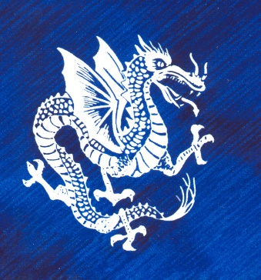

Technology Director

**Mrs.Bennett**

**How to do your banner**

We used Verdana 36 pt for top word art

Verdana 24 pt for bottom word art

Select all and group

Right click and save as jpeg with smallest size